Pre-Owned Merchandise

In this project we have completed following functionalities

1. Admin Login: admin can login to system using username and password as ‘admin and admin’. After login admin can view all registered users, list of available products and feedback and ratings of different products
2. New User Sign up: new user can create profile to sign up with the application
3. User Login: any seller or purchaser can login to system, seller can add product details, buyer will search products based on category, price range and locations and can view all retrieve product details along with photo. Buyer can get owner contact number to confirm purchase deals. Users can add feedback and ratings to desired products

Note: u ask for real time transactions but it required real account and pan card details to setup real transaction which is not possible in academic projects.

To run project install python and then install all packages given in requirements.txt file and then install MYSQL database and then open MYSQL console and then copy content from DB.txt file and paste in MYSQL console to create database.

Now double click on ‘run.bat’ file to start python server and get below page.

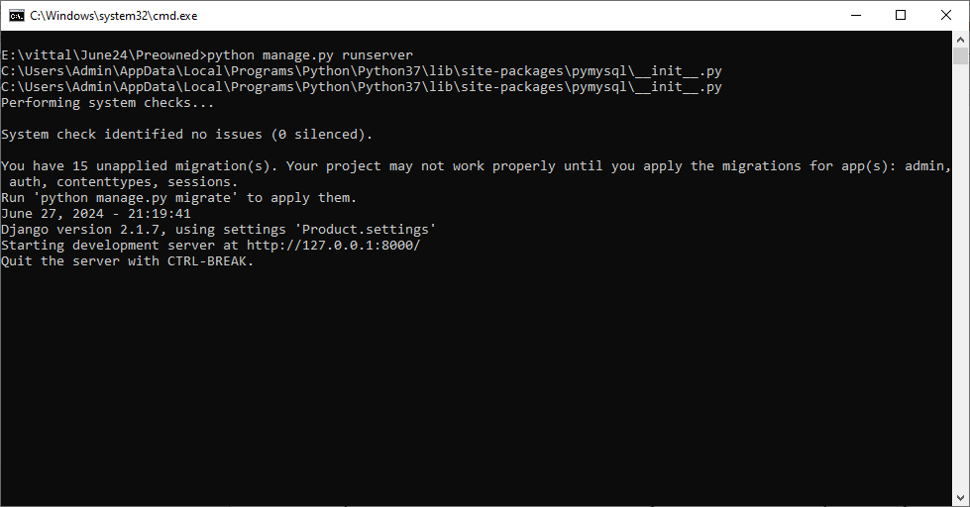

In above screen python server started and now open browser and enter URL as <http://127.0.0.1:8000/index.html> and press enter key to get below page

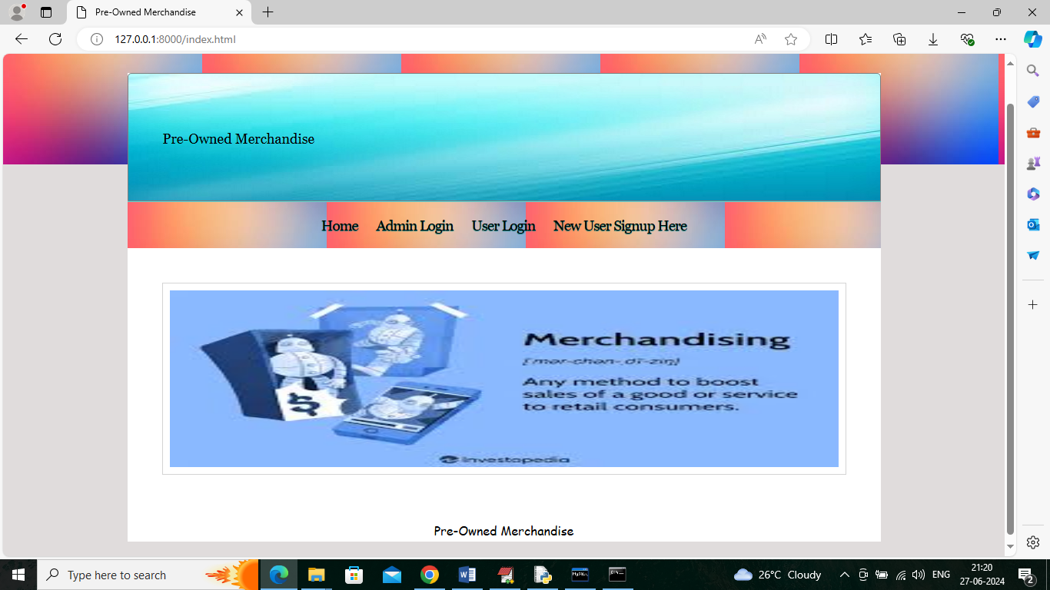

In above screen click on ‘New User Signup Here’ link to get below sign up page

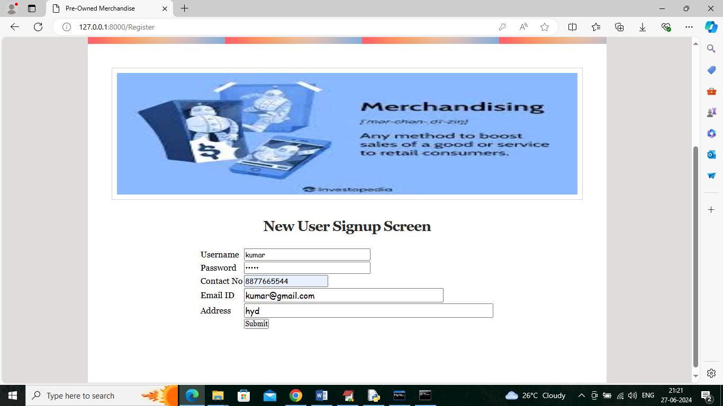

In above screen user is entering sign up details and then press button to get below page

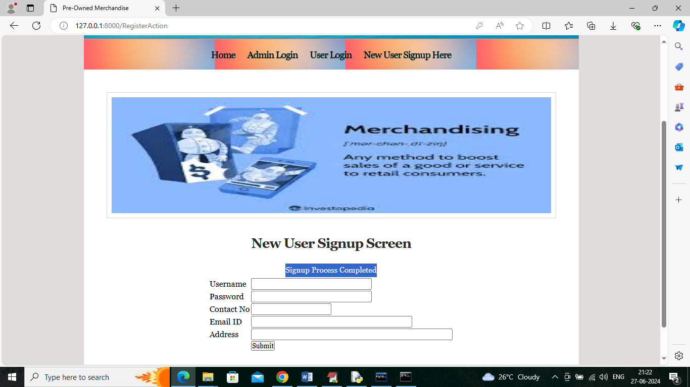

In above screen sign up task completed and similarly you can add any number of users who can login as seller or buyer. Now click on ‘User Login’ link to get below page

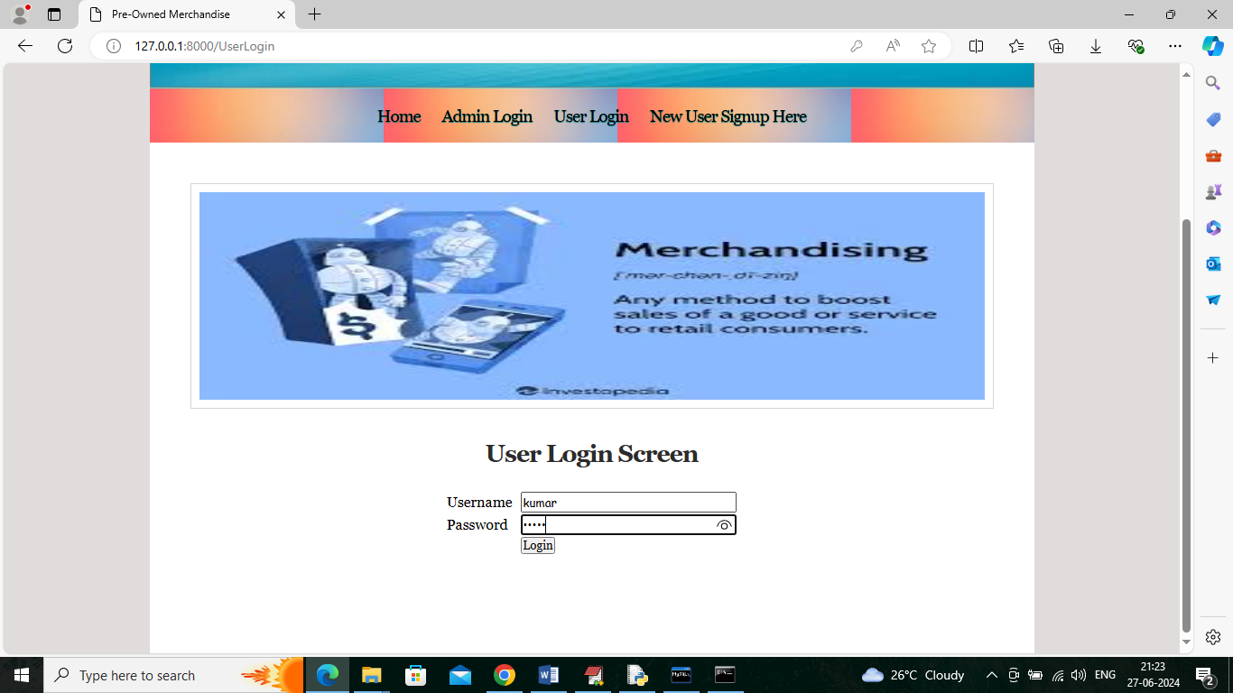

In above screen user is login and after login will get below page

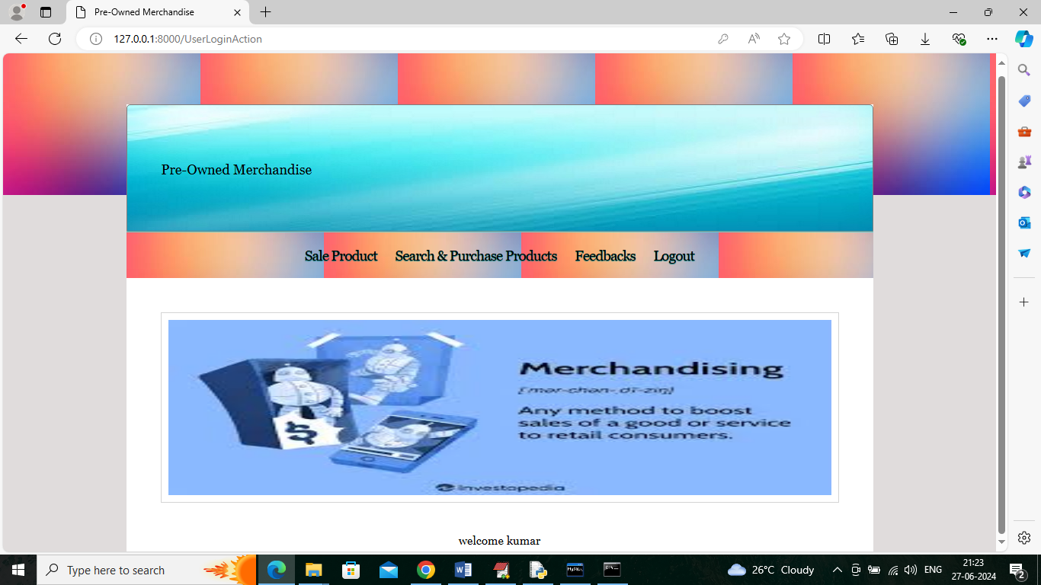

In above screen user can click on ‘Sale Product’ link to add product details like below screen

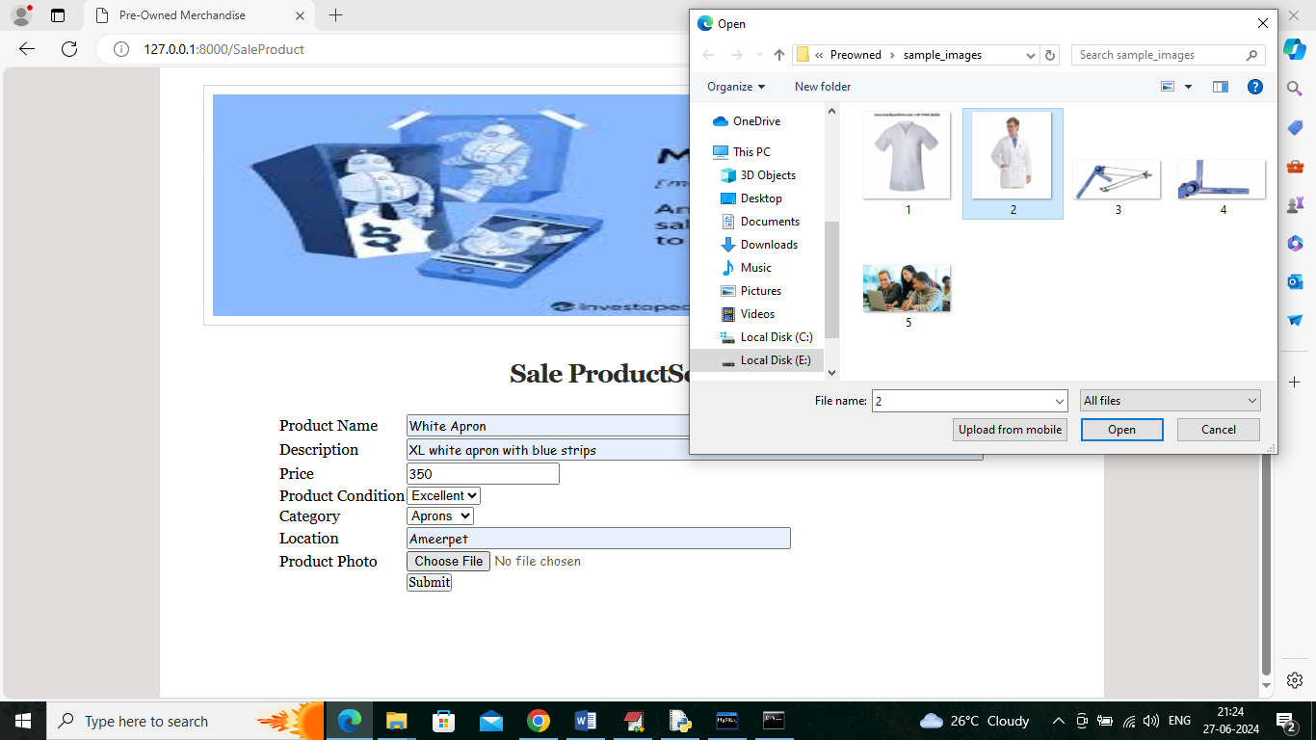

In above screen user is adding new product details and then uploading related images and now click on ‘Submit’ button to get below page

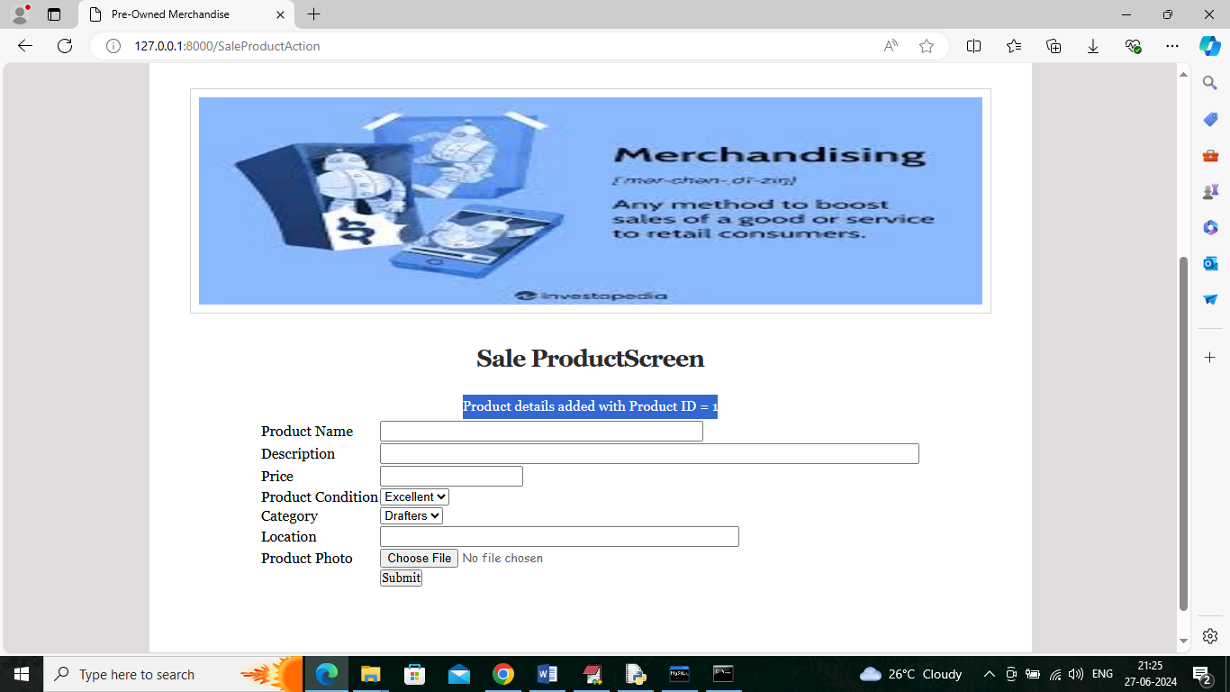

In above screen product details added with product id as 1 and similarly you can add any number of products

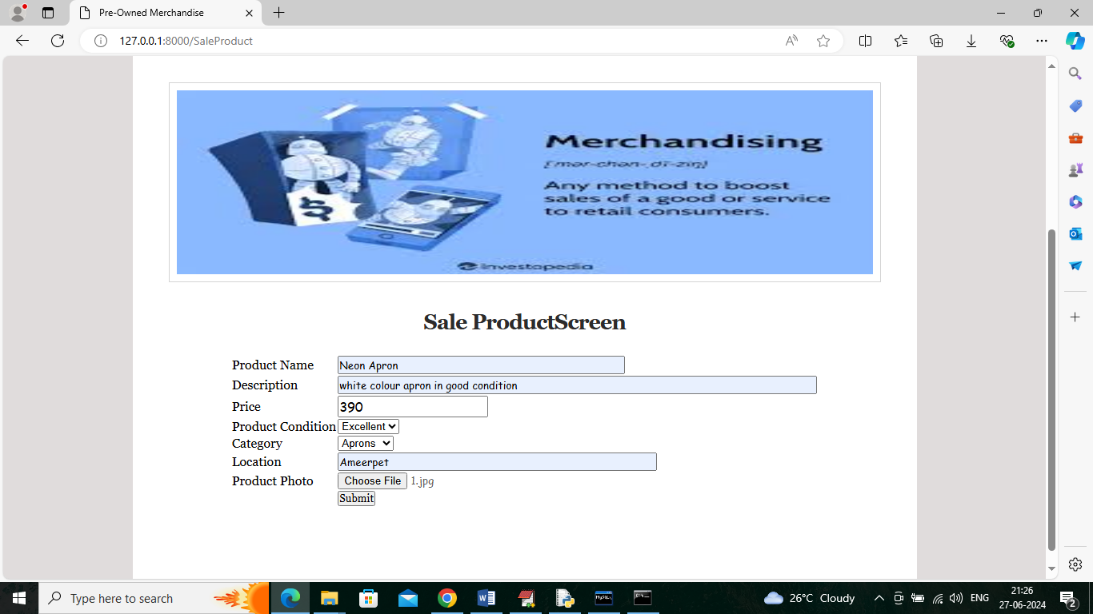

In above screen adding another product details and now logout and login as another user to view or search products

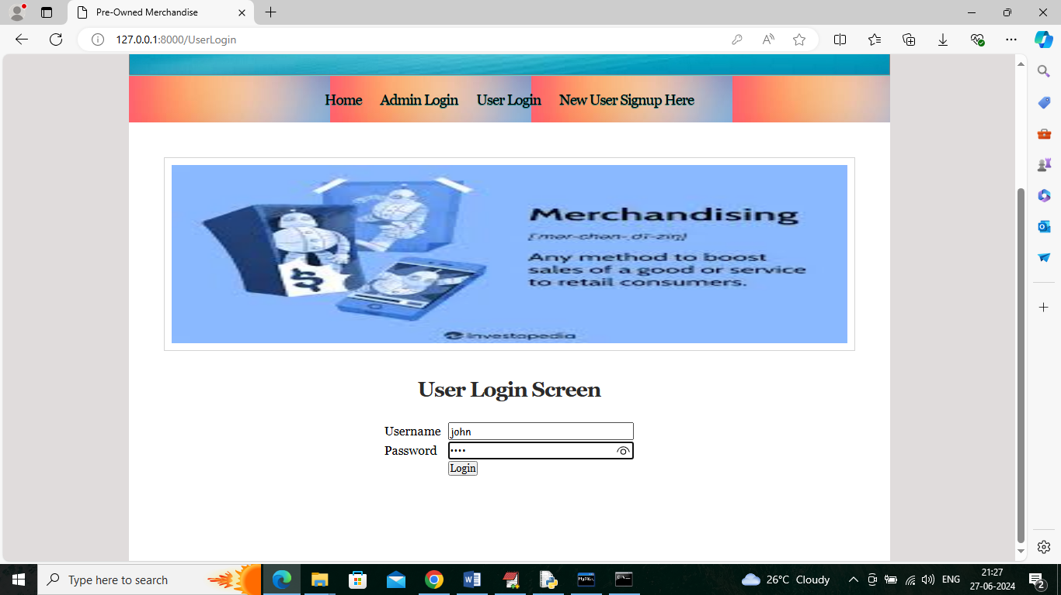

In above screen other user is login and after login will get below page

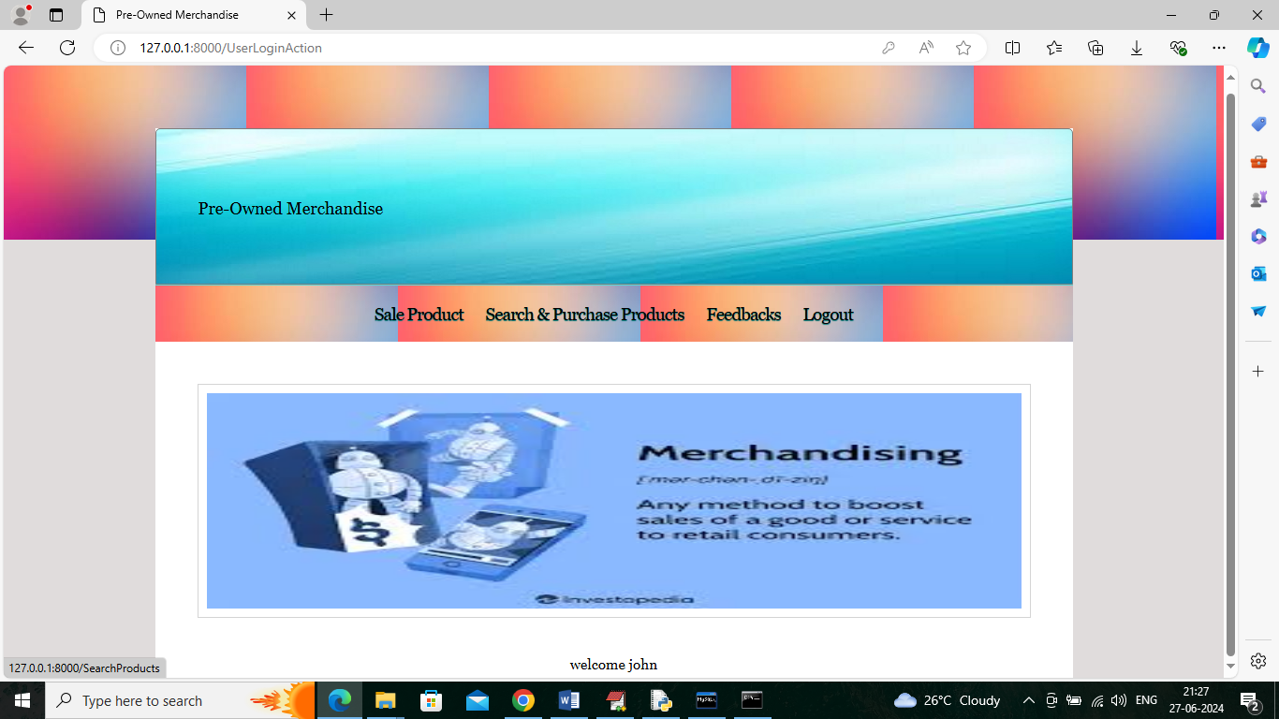

In above screen user can click on ‘Search & Purchase Products’ link to get below page

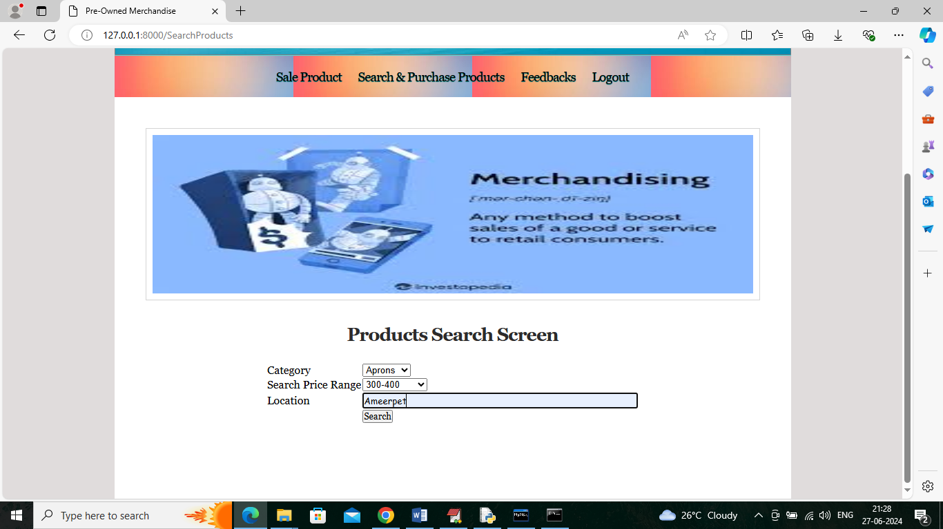

In above screen user is selecting desired product search criteria and then press button to get below search page

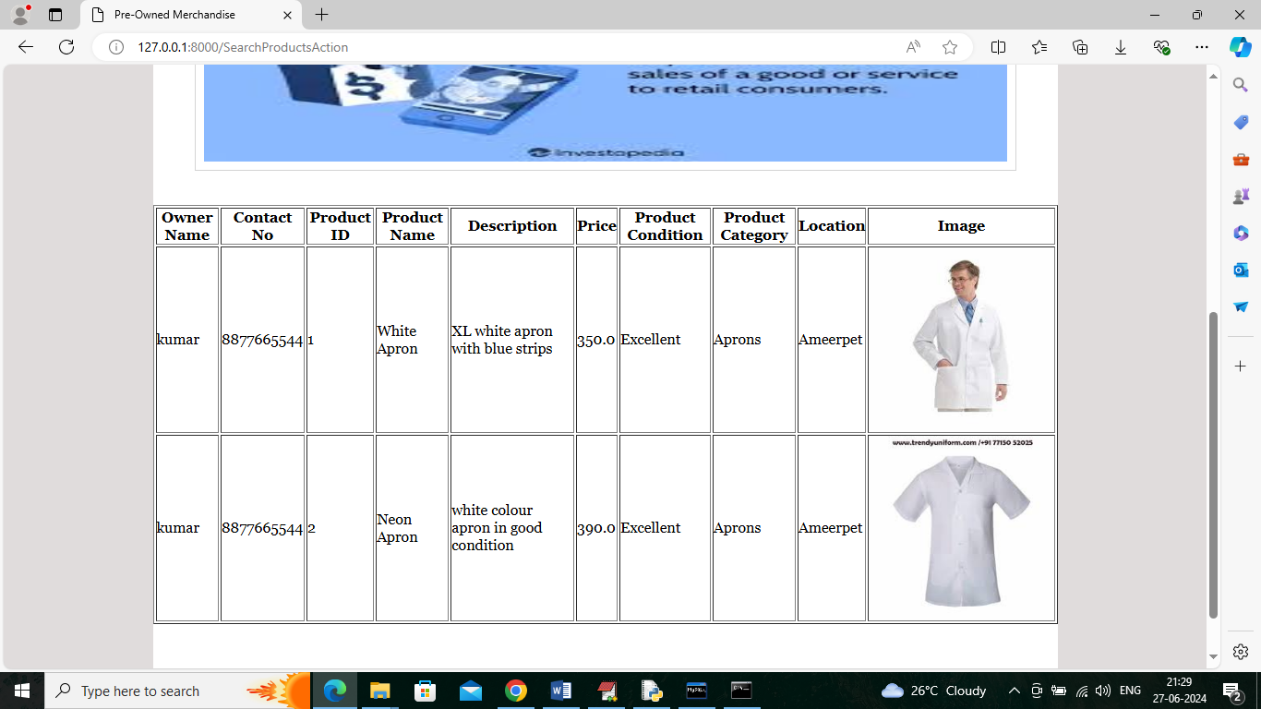

In above screen user can see all product details based on search criteria and user can see owner name and contact number to confirm purchase and now click on ‘Feedback’ link to give feedbacks

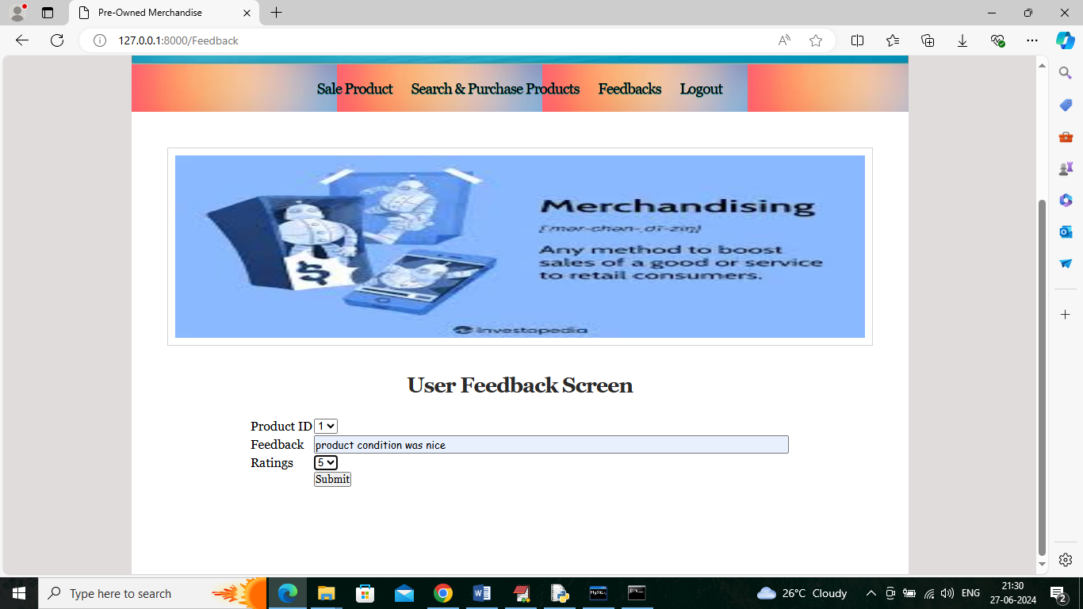

In above screen user will give ratings and feedback for selected product and then click on ‘Submit’ button to save feedback

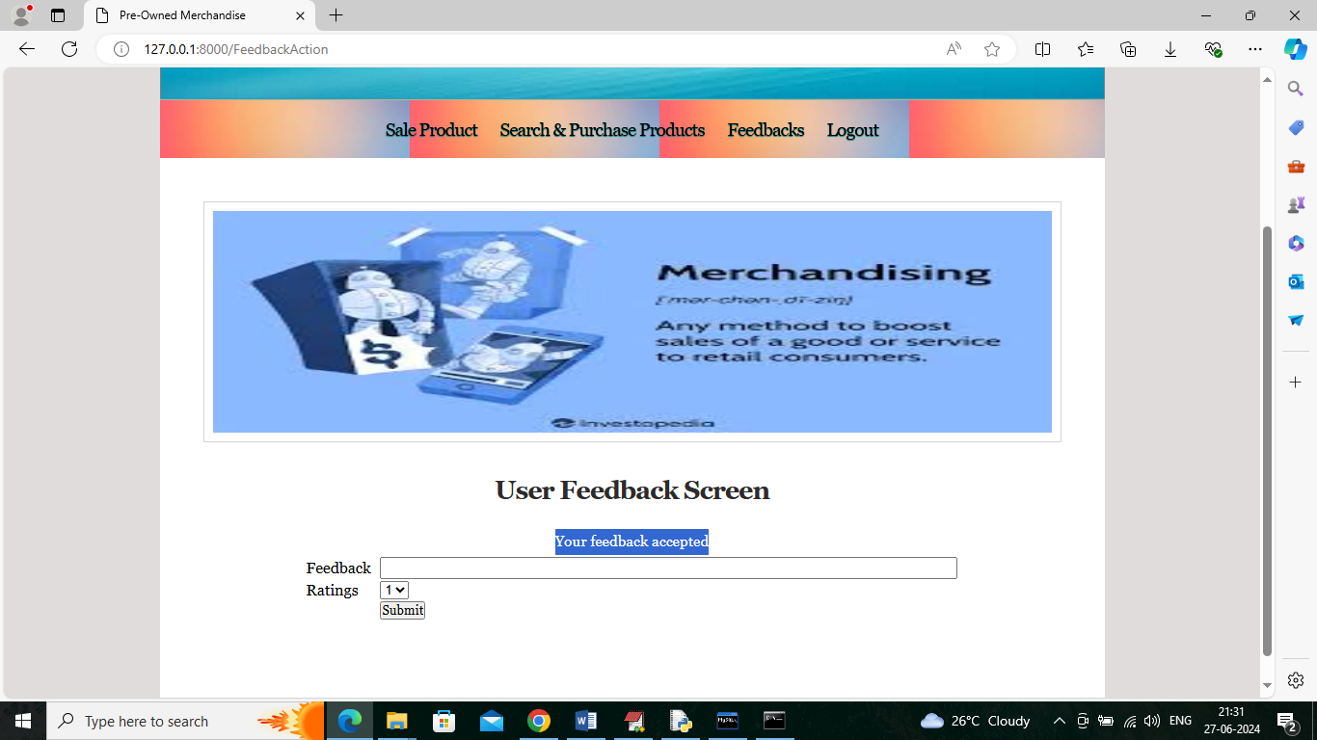

In above screen user feedback accepted and now logout and login as ‘admin’ to view all details

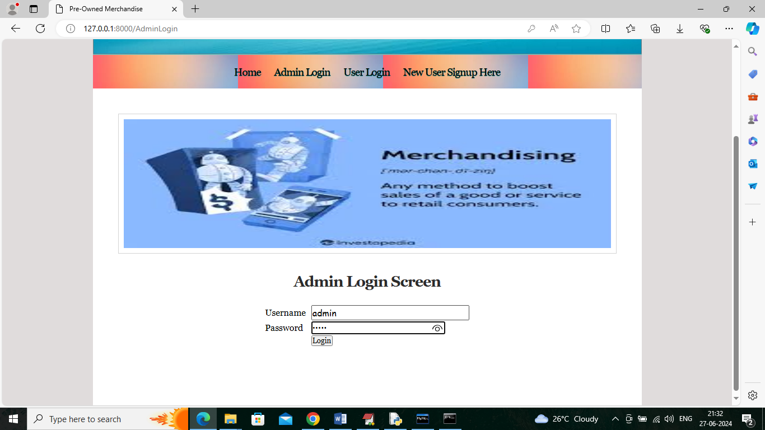

In above screen admin is login and after login will get below page

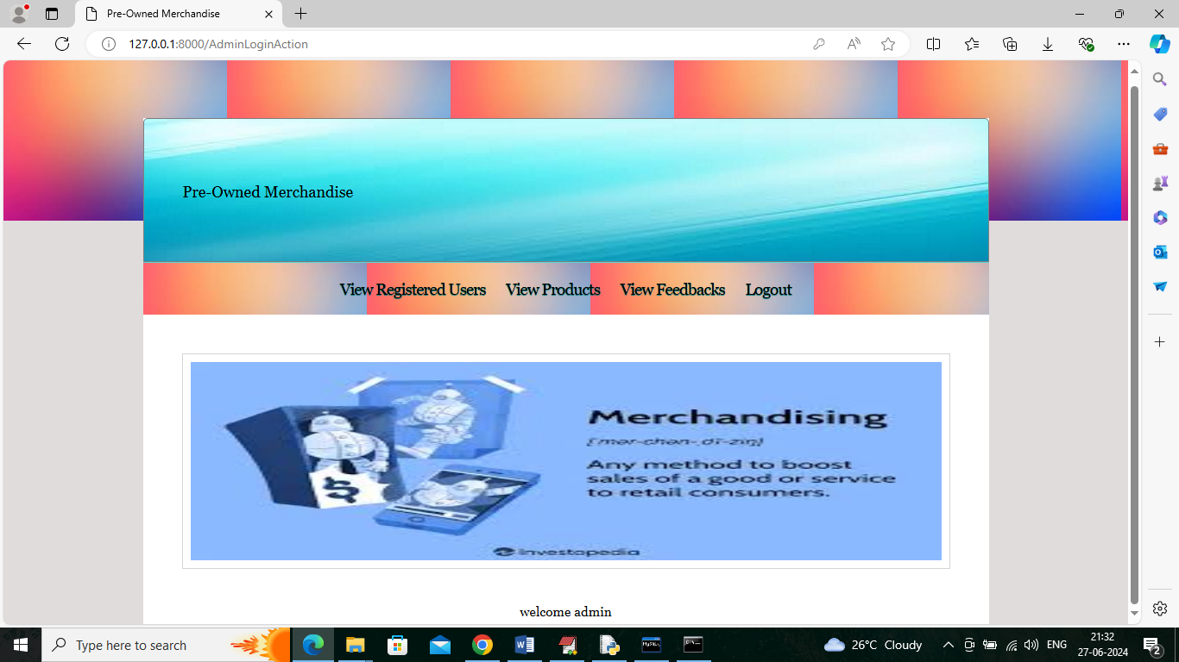

In above screen admin can click on ‘View Registered Users’ link to view all user details

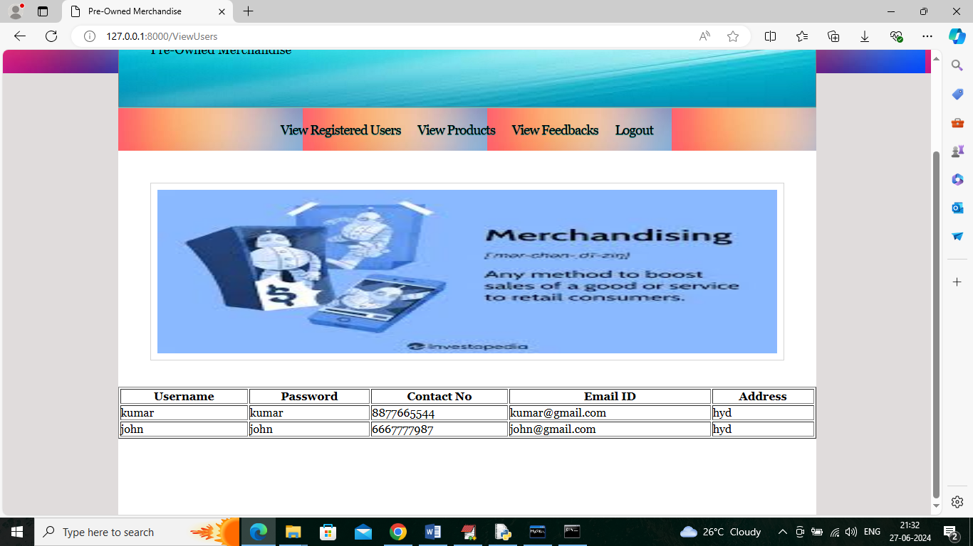

In above screen admin can view user details and can click on ‘View Products’ link to get below page

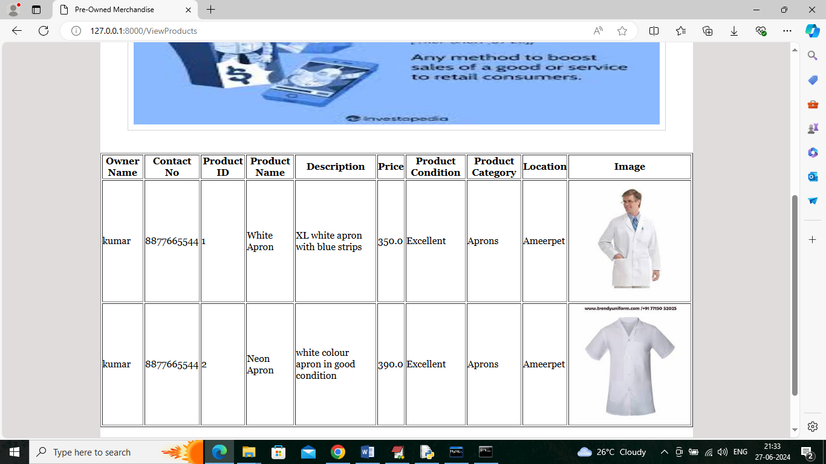

In above screen admin can view list of available products and now click on ‘View Feedback’ link to view all feedbacks like below screen

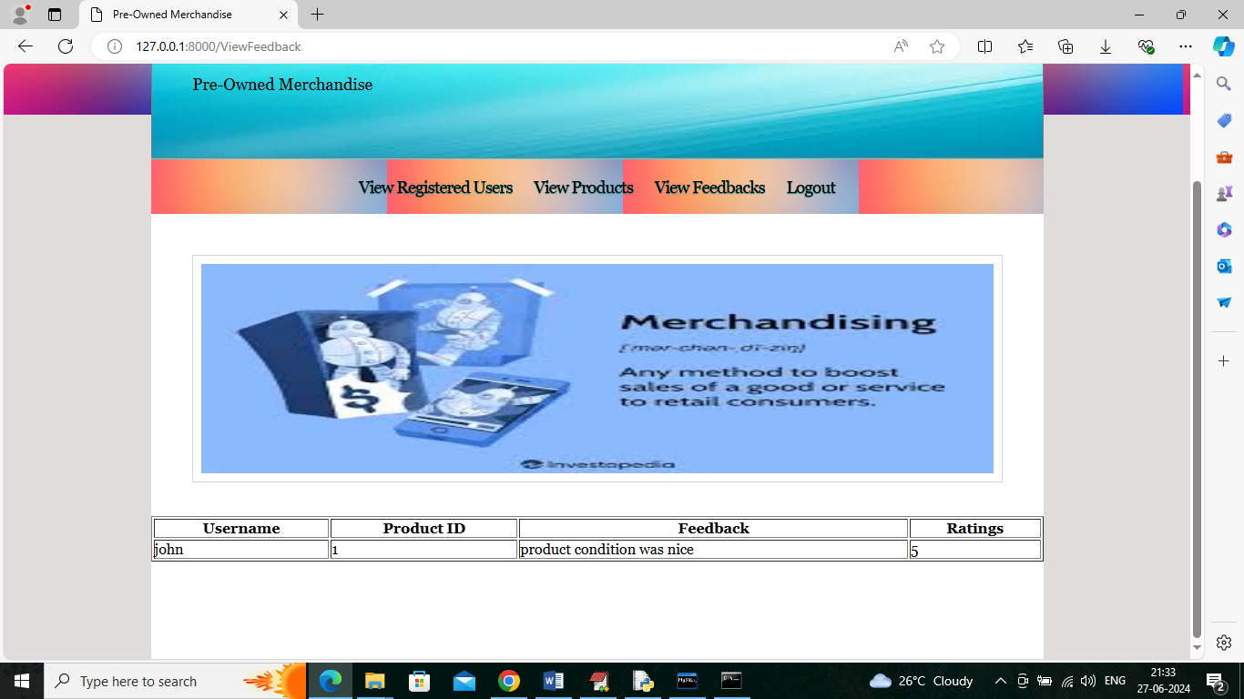

In above screen admin can view all feedbacks from all users.

Similarly by following above screens users can sale or purchase merchandise products